The 5-Second Wind Test: How I Automated One of Structural Engineering's Most Tedious Mapping Tasks
Imagine it’s late Thursday night. You are tasked with designing a new high-rise building right in the heart of a bustling city. Before you can size a single column or specify the thickness of a window pane, you need to answer one crucial, legally binding question: How hard is the wind going to slam into this building?
To find out, building codes—like the NSCP 2015 (National Structural Code of the Philippines) and ASCE 7-16—force you to do something incredibly tedious. You have to slice the map around your site into an 8-directional pizza wedge. Then, for every single slice, you must peer 1,524 meters (5,000 feet) upwind to analyze the terrain.
Are there buildings blocking the wind (Exposure B)? Is it wide-open land (Exposure C)? Or is it unchecked, dangerous open water (Exposure D)?
Traditionally, this meant printing out satellite images, pulling out a digital ruler, eyeballing rows of houses, and spending two hours guessing.
I got tired of guessing. So, I built a desktop application to automate it. To prove how it works, let’s look at a real-world project site and put the tool to the test.
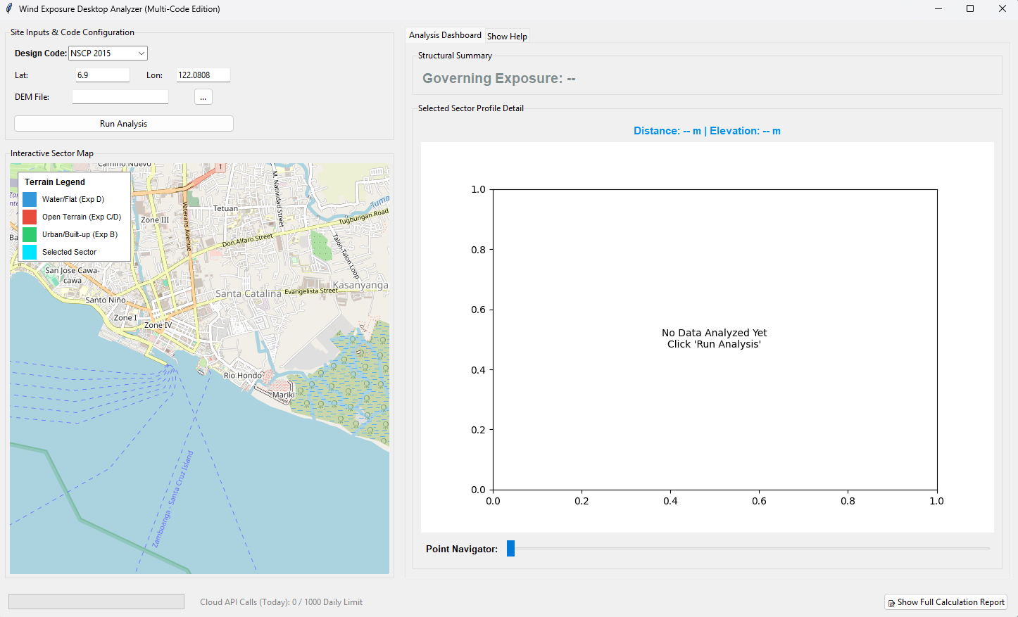
Testing the Tool: A Real-World Challenge
To see the tool in action, I decided to test it using the coordinates for Ayala Malls Circuit Makati. It’s a fascinating engineering test case. To its north and west, it is bordered by the winding Pasig River. To its south and east, it’s surrounded by a hyper-dense jungle of residential and commercial buildings. It is a chaotic mix of water, open areas, and urban skyscrapers.
Instead of spending hours tracking this down manually, here is how the tool handles it:
- I opened the application and selected the NSCP 2015 design code.
- I typed in the exact coordinates for the site: Latitude: 14.57302, Longitude: 121.01953.
- I clicked "Run Analysis".
In less than 5 seconds, the loading bar raced across the bottom. The blank map erupted into a beautifully color-coded radar of overlapping wedges, and a clean terrain cross-section graph snapped into view.
No drawing, no manual measuring, and zero guesswork.

What Just Happened in Those 5 Seconds? (The Technical Magic)
While the user just sees a fast, satisfying interface update, the code underneath is running a multi-layered engineering evaluation:
1. The 1.5-Kilometer Geometry Sweep
The moment "Run Analysis" is triggered, the program calculates the precise boundaries for all 8 sectors (North, Northeast, East, etc.). It maps out coordinate sampling points stretching exactly 1,524 meters into the distance at 30-meter intervals.
2. Live 3D Satellite Terrain Sourcing
Because the tool is built for flexible workflows, it checks if you've uploaded a local 3D terrain file (a Digital Elevation Model). Since I didn't load one for this quick test, the built-in Code Abstraction Layer seamlessly made a cloud API call to fetch high-resolution SRTM 30m elevation profiles for every single coordinate point along those 8 sectors.
3. Quantitative Object Detection
Instead of a human "eyeballing" the map, the application runs a mathematical calculation on the changes in elevation ($\Delta h$) from point to point:
- Water/Flat surfaces: Ground variations less than 0.05 meters are automatically flagged as flat terrain.
- Urban Obstructions: Jagged elevation changes of 0.50 meters or greater are flagged as structural or natural wind shields.
The tool then runs these percentages against strict code rules. For example, under the NSCP 2015 configurations, a sector must be heavily shielded—at least 80% urbanized within the first 1,000 meters—to safely earn a cost-optimized Exposure B rating.
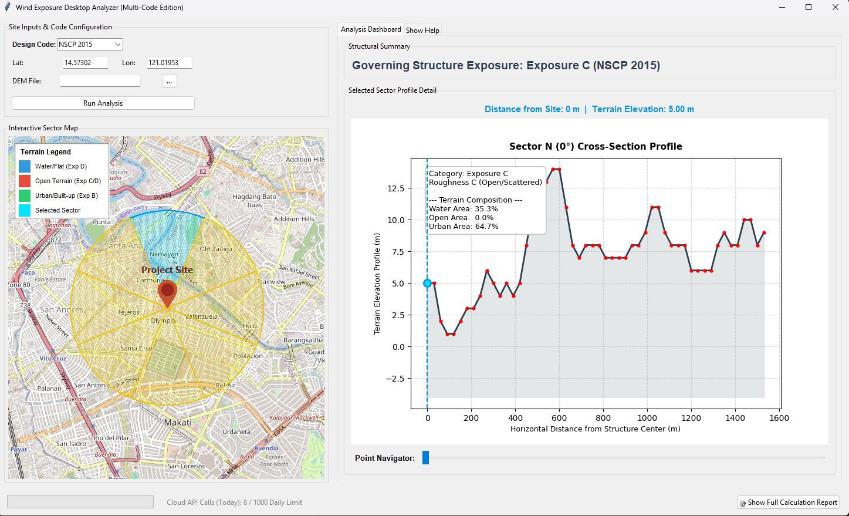
Exploring the Visual Dashboard
The power of the tool is how it displays data for both engineers and non-technical managers.
The Interactive Map acts as a visual status report. Sectors turn Green for heavily built-up urban shields, Red for open areas, and Blue for flat water hazards. Looking at our test site, you can visually track how the sectors slicing across the Pasig River automatically flag the potential for high-velocity wind pathways.
If you click on any sector wedge, the Selected Sector Profile Detail instantly updates. It gives you a side-profile view of the earth's surface. I included a Point Navigator slider that allows you to walk step-by-step along the 1.5-kilometer wind path. As you slide it, a blue cursor moves along the graph, telling you exactly how high the terrain rises or falls at that specific distance from your building.

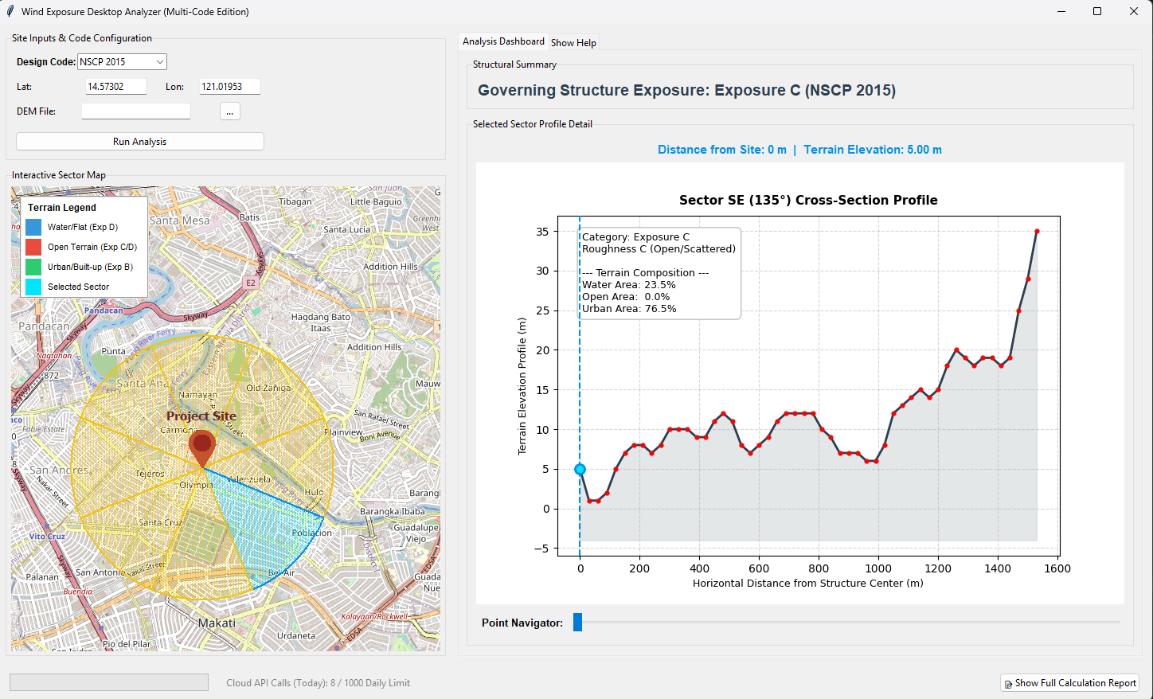

Deep Dive: Breaking Down the Wind Pressure Equation
To understand why automating this 8-sector exposure analysis is such a game-changer, we have to look closely at the variables inside the governing velocity pressure equation processed by the application's reporting engine:
$$q_{z}=0.613 K_{z} K_{zt} K_{d} V^{2}$$
Each variable acts as a mathematical modifier to scale the true physical force of the wind based on where and how a building is constructed. Here is exactly what they mean and where they come from in the design codes:
$q_{z}$ – Velocity Pressure
- What it is: This is the final calculated wind pressure acting at a specific height ($z$) above the ground. It tells engineers the raw pressure (in Pascals or Newtons per square meter) that the structure must safely withstand.
- Code References:
  - NSCP 2015: Section 207A.10
  - ASCE 7-16: Section 26.10.2
$K_{z}$ – Velocity Pressure Exposure Coefficient
- What it is: This factor accounts for how wind speed changes with height and terrain roughness. Wind moves slower close to the ground due to friction from trees and buildings, but speeds up significantly the higher you go. This is the exact variable our tool solves. To find $K_z$, you legally must know the Exposure Category (B, C, or D) across all 8 sectors.
- Code References:
  - NSCP 2015: Section 207A.7.2 & Section 207A.7.3
  - ASCE 7-16: Section 26.7.2 & Section 26.7.3
$K_{zt}$ – Topographic Factor
- What it is: This variable accounts for wind "speed-up" effects. When wind slams into a sharp geographical feature—like an isolated hill, a ridge, or a steep cliff (escarpment)—the wind compresses and accelerates over the top, subjecting buildings on ridges to much higher forces.
- Code References:
  - NSCP 2015: Section 207A.8
  - ASCE 7-16: Section 26.8
$K_{d}$ – Wind Directionality Factor
- What it is: A statistical factor that accounts for the reduced probability that the absolute maximum windstorm velocity will hit the structure from its worst possible, most structurally vulnerable direction. It typically ranges between 0.85 and 0.95 depending on the building shape.
- Code References:
  - NSCP 2015: Section 207A.6
  - ASCE 7-16: Section 26.6
$V$– Basic Wind Speed
- What it is: The baseline peak gust wind speed (typically measured at 10 meters above the ground in open terrain) mapping to your geographical region. In the Philippines, this value changes significantly depending on whether you are building in a typhoon-prone coastal zone or a shielded interior valley.
- Code References:
  - NSCP 2015: Section 207A.5 & Figure 207A.5-1A/B/C (Wind Maps)
  - ASCE 7-16: Section 26.5 & Chapter 26 Wind Speed Maps

The Paper Trail: Generating Legal Proofs
In structural engineering, you can never just say, "Well, my app told me so." If a building official audits your project, or if a peer reviewer challenges your wind design, you have to prove your math.
To solve this, I added a "Show Full Calculation Report" button. Clicking it generates an audit-ready engineering document right on your screen.
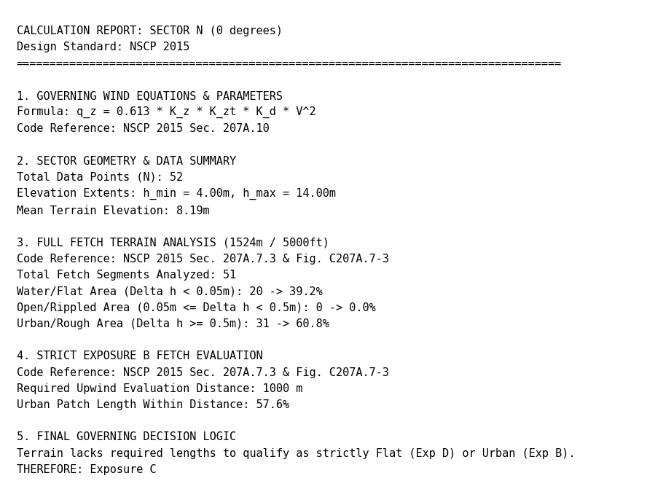
This window displays the exact wind pressure formula $q_{z}=0.613 K_{z} K_{zt} K_{d} V^{2}$, references the exact chapters of the building code used (e.g., NSCP 2015 Sec. 207A.7.2), prints the raw terrain statistics, and outputs a plain-text logic statement detailing why the system made its final decision. It turns a complex algorithm into a transparent, legally compliant receipt.

Final Thoughts
By converting static structural textbooks into automated, geographic code, this desktop analyzer eliminates hours of tedious clicking and removes the dangerous element of human bias from site analysis. It ensures that developers don't waste money over-designing buildings out of fear, while giving engineers absolute mathematical confidence that their structures are safe against nature's toughest elements.
Tech Stack Used: Python 3.x, Tkinter, Matplotlib, Geopy, TkinterMapView, Rasterio, OpenTopoData SRTM API.

How are you evaluating site exposures for your current projects? Let's talk about the future of automation in structural engineering in the comments below!

